The Farningham & Eynsford Local History Society
Founded 1985
A Charitable Company Limited by Guarantee
No. 5620267 incorporated the 11th November 2005 Registered Charity 1113765
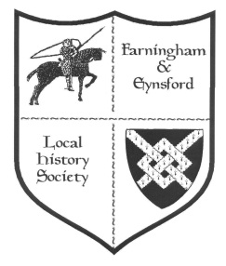
(Original Society founded 1985 Registered Charity no 1047562)
Bulletin No 117
March 2018
NOTICE OF ANNUAL GENERAL MEETING 2018
The AGM will take place at Farningham Village Hall on Friday 18th May at 8.00pm (doors open 7.30pm).
BEFORE THE AGM
Browse through the photographic collection
AGM AGENDA
1. Welcome
2. Apologies for absence
3. Minutes of last AGM acceptance
4. Matters arising
5. Adoption of Accounts
6. Setting of Subscription Level for 2019
7. Chairman's Report & supporting reports
8. Election of Officers and Committee (new nominations welcome)
9. Election of Directors
10. Any other business
Forthcoming Talks and Events
Date Details Where
2018
27th April The discovery of the Saxon Palace in Eynsford
- Brian Philp EVH
28th April Eynsford Shops Exhibition 11am to 4pm, The Library
Castle Hotel, Eynsford
18th May AGM – Photographs on display from the FELHS
Collection. AGM followed by light refreshments FVH FVH
21st September Kent on Film – Rural Life – Kent from 1890s into
The 20th century EVH
2nd November Members evening – Powerpoint presentation by Susan
Pittman showing aspects of Crockenhill, Eynsford and
Farningham after WWI ended. Display compiled by Jan
Wilkes and Barbara Cannell following the lives of some
of Eynsford ex-servicemen once they returned home. FVH

In the pipeline: -
Farningham Shops & High Street Exhibition (date and venue to
be arranged)
Unless otherwise stated all Meetings are held on a Friday evening from 7.30 pm, talk commencing 8 pm. (Note: front row seats can be reserved for members with hearing or eyesight difficulties and hearing loops are now available on request)

Thinking about Guy
It was with sadness that I heard about the death of Guy Hart Dyke. I had known him for about 20 years. When I came to live in Eynsford I worked at Lullingstone Roman Villa and now and again Guy would pop in to see how things were going. Whenever I saw him, I used to mention some idea I had come up with for an event at the castle, he was always polite and just smiled, but as we all know there was the grand idea to create the World Garden. A television programme followed ‘Saving Lullingstone’ which made celebrities of the (Hart Dyke) family, Guy took it all in his stride.

In recent years I have been lucky enough to work at Lullingstone during the Summer months, so I have seen more of Guy and Sarah. Guy was always interested in what I was up to regarding local history and one day when we were not very busy he showed me his precious photograph albums. Whenever I arrived for work most times I would find Guy sitting in the porch ready and waiting for visitors and I would always say to him ‘I’m here’ and he would always reply ‘Well done Jan’ (It’s always the little things people say that we remember)

I have the greatest admiration for Guy and Sarah and what they have achieved over the last 40 years or so in keeping Lullingstone Castle in the family and I am sure I speak for the Chairman and Committee of the History Society when I say Lullingstone Castle will not be the same without Guy Hart Dyke.

Jan Wilkes

REPORTS FROM COMMITTEE
CHAIRMANS REPORT (Barbara Cannell 01322 864253)
The start of another year, one which I know will bring some changes to the society.
One of these changes, which those members who came to the evening meeting in February will already know about, is my decision to resign from my role as Chairman at the forthcoming AGM. I will also be resigning from the committee and being responsible for the society publications.
After 16 great years this was not an easy decision to make but I think the time has come for me to stand aside but be assured so long as there is history I will be there somewhere.
During those 16 years I have been involved with many exhibitions. Notably for me three days in 2009 at Lullingstone Roman Villa ‘The Roman Household’ showing how the Romans lived and what they ate and in 2010 a history month when there were exhibitions at Eynsford, Farningham and Crockenhill village halls celebrating 25 years of the society. Numerous times at village fetes, through rain, wind and boiling hot sunshine. There have been evening meetings and special events with many speakers and interesting subjects from a Magician to a young man who went down to the wreck of the Titanic. Outings to Hythe, Isle of Sheppey, Whitstable and the Royal Engineers Museum at Woolwich. History conferences and latterly helping to put together exhibitions at the Castle Hotel and St. Martin’s Church. I am so proud that I was able to help with the restoration of the photographs of the World War One service men which hangs in Eynsford village hall and the concert where we remembered the battle of the Somme. I am sure there are other things that will come to mind later but during my time as Chairman I have met some wonderful and interesting people, some who have become close friends.
One of FELHS achievements was the acquisition of the archive centre in Eynsford. It is now, with the help of various committee members and volunteers proving to be one of the best resources for history in the area.
Committee members have come and gone and sadly we have seen some of our oldest members pass on. I would like to thank all of you for your support for without you the history society would not exist. Please support your new Chairman and Committee and help them to continue gathering and preserving the history of our villages.
I look forward to seeing you at the AGM in Farningham village hall on the 18th May when we can raise a glass of wine and toast the future.

RESEARCH REPORT (Susan Pittman 01322 669923 www.felhs.org.uk)
www.martinsbank.co.uk Farningham
1922 January Opened by Bank of Liverpool and Barclays Ltd.
1928 January 3 Martins Bank Ltd.
1969 December 15 Barclays Bank Ltd.
2017 September 1 Closed permanently from noon
The website has various exterior and interior photos of the bank.

Lost Film of Eynsford by George Eves
Our Chairman has found a newspaper cutting dated 17 May 1940, which refers to a film 'Eynsford' made by George Eves using local actors and actresses. Another film, made in 1940, was about the AFS (Auxiliary Fire Service), on which he was serving. The film had secured an award in an annual amateur cinematography exhibition and had been shown in several London boroughs. George Eves lived opposite the war memorial.

War-time Mobile Canteen, Lullingstone
Lady Zoe Hart Dyke was running this WVS (Women's Voluntary Service) mobile canteen at Lullingstone Castle. It was widely used by the troops stationed there, but it also provided hot drinks and sandwiches in the early hours of the morning for people rendered temporarily homeless by air raids. The appeal was for volunteers within a radius of five miles to help one night in the week.
(Dartford Chronicle and Kentish Times 22 November 1940)

A History of The Homes for Boys in Hextable 1883-1956
This well produced book by Greg Daxter was published in about 2013. This Home (called the Swanley Homes) is perhaps less well known than the Farningham Homes for Little Boys, but in fact the two institutions were run side by side. The book covers the early provision for destitute children and includes the early history of the Farningham Homes. The difference between the two was that Farningham catered for boys who were homeless and orphans without means of support. Their upkeep was provided by subscribers. At Swanley the orphans had families that could contribute something towards their upkeep, with the rest made up by donations. The Homes became Furness School.

Christopher Percy Casstine - Photographer
I have referred in an earlier Bulletin to this photographer and have been curious about his background. More recently I have come across a photograph by him of the royal train travelling through Swanley carrying Queen Victoria to Dover in 1896. Greg Daxter's book gives details about Casstine. He was born in 1867, the youngest of six children of Robert and Christina. His father died in 1870 and his mother in 1872, following which Christopher was sent to an orphanage in Hertfordshire. Perhaps it was there that he learned the art of photography. In 1884, still a teenager, he headed the list in the Swanley Homes Staff Register, as an officer and photographic artist. He taught photography at the Swanley and Farningham Homes until 1903, when he set up his own business. One of his important patrons was Arthur Mee, who employed him as photographer for many of his books and magazines. He married Bertha Lane, the daughter of local baker, Edwin Lane and they lived on the Main Road, Swanley, next to the Methodist Chapel.

Pollution of the river Darent from Lullingstone Castle
In 1899 Dartford Rural District Council heard from the Medical Officer of Health that during a visit to Lullingstone Castle he had found that 'the drainage runs directly into a branch of the river, causing very serious pollution. This must be stopped forthwith, as many of the dwellings in Eynsford have no other than the river water, which is practically sewage.' On a further visit the Medical Officer of Health had found sewage and paper floating in a ditch leading from the Castle into the river. Also, Sir William Hart Dyke had not laid on water to his cottages meaning that tenants had no other water than the river to use. Sir William Hart Dyke took exception to this report and had ordered his own inspection by a sanitary engineer, who said the water quality was satisfactory. There was heated discussion at the Council meeting as to whether legal action should be taken, but in the end it was decided to order a bacteriological analysis of the water.
(Dartford Chronicle and District Times 14 November 1899)

Success of Cottage Gardening in Eynsford
The ubiquitous Elliott Downs Till put some of his energies in the late 1890s into Cottage Gardening as revealed in the minutes of the Kent Technical Education Committee, whose reports I have been reading while researching farming in Crockenhill. In its report of 19 May 1897 Eynsford was cited as the best centre with crowded rooms and enthusiastic meetings. Thanks to Mr Till several initiatives were introduced - exhibitions of garden produce, honey and eggs, with prizes awarded out of admission fees. The inspector also noted the series of visits to demonstrate practical work in fruit growing. The following year attendance reached 100 with lectures showing evidence of all-round appreciation. At the time 29 centres were listed throughout Kent. Eynsford had the highest average attendance of 50.8, followed by Foots Cray with 39.5, while nearby Sutton-at-Hone was poorly attended with an average attendance of 9.
(KHLC CC/MC/12/1/3 & 4)

A lamentable state of things at Crockenhill
A long newspaper column was devoted to this story. It concerned the large allotment field (over 18 acres) with 85 allotment holders, the right of way to which was being obstructed by John Wood, a prosperous local fruit farmer, with 'a large heap of decaying vegetable matter in the shape of cabbage stumps and leafage.' Action was taken and the whole lot consumed by fire, only to have another nuisance in the form of smelly and decaying tomato plants deposited. Harry Wise junior as secretary of the local Allotment Holders' Association raised the matter on behalf of the allotment holders with John Wood. This was brave (or perhaps unwise! - not meant to be a pun!) because he was a tenant of John Wood, who proceeded to evict him and his young wife. The newspaper reporter wrote that 'The Wises are a highly respectable family, and Mr Wise junior occupies a responsible position at Messrs. Cannell's Nurseries.'
(Dartford Chronicle and District Times 9 July 1895)
N.B. There are still members of the Wise family in Crockenhill, descendants of John Wood still own land there.

Dartford Union Minutes, 1852-1854
Guardians - Eynsford Thomas Ray
Farningham William Smith
Lullingstone William English
Chairman of the Board of Guardians Sir Percival Hart Dyke

The Five Bells, Eynsford in a filthy and unwholesome condition, notices served on Mr Tasker, the brewer and owner. These were complied with, and the privy emptied and the stag ponds cleaned out.
George Barr's 3 children were admitted after his death. Officers from Eynsford were ordered to take his personal effects and household furniture to be sold towards their maintenance.
Sarah Smith of Eynsford to be removed to the County Asylum.
New cottages in Crockenhill were to be valued for poor rates.
Richard Morgan to have proceedings taken against him for deserting his wife.
Mr Everest of Farningham to be reprimanded for entering cases in the Medical Officer's book for medical relief without referring them to the Relieving Officer.
Maria Hills and children were refused acceptance by Bromley Union because their late father, John Hills, had Lullingstone as his place of settlement.
Mary Nurley's father, George Nurley, to be examined as to his place of settlement. Mary was single and would be sent back to that place. George Nurley was ostler of the Star Inn, Maidstone.
Table of dietary amounts for the able-bodied poor showed little variation in fare. For breakfast bread, butter and gruel; for dinner bread, meat pudding, suet pudding, cheese, broth; for supper bread, butter, gruel.
(KHLC G/Da/AM9)

General enquiries
Lidos along the Darent - Rod asked for information about lidos along the Darent following the discovery of one in Sundridge from the 1920s.
Farningham airfield - The Airfields of Britain Conservation Trust is hoping to put a commemorative plaque on the site. Although the airfield bears the name of Farningham, it lies outside the parish, so I suggested that the enquiry be directed to Horton Kirby or Sutton-at-Hone.
Local names for birds - Kerstin, a PhD student from the University of Regensburg (Bavaria), is researching the English linguistics of names used locally for birds now and in the past. I said I would pass on the request but could not think of anything in our collection of immediate use.
Lambourne's Tail Lifts and Shutter Repairs (formerly at Whitepost Hill) - Back in 2013 Ellis Johnston, the managing director at the relocation site in Crayford, requested information about the company. In November 2017 he visited the Centre and went through what we had, including a scrapbook donated by Mrs Lambourne and compiled by her husband, Mervyn.
The Mill development, Farningham - Graham, secretary of the Residents' Association, wanted to build up a documentary and photographic archive. I shared what we had in our collection and was also able to let him copy images of the mill donated by Hilary Harding. (see Donations below)
Farningham Home for Little Boys - These enquiries I direct to our website which gives details of who to contact, because it lay outside our area. This time a request came from Anne, whose husband was at the Home after the death of his mother in 1942.
Local folklore - Kerry wanted local folklore stories for her son's homework! As ideas were needed immediately the best I could do was to tell her about the Lullingstone ghost - a lady in grey who glided across the lawns before disappearing through a wall, and rumours of Arthur Mee being a German spy. It would be interesting to learn of any folklore stories local to our area that readers can tell.
The Manor House, Farningham - Krishna wanted to find out the history of the house. He and his daughter spent several hours in the Centre looking through the collection and has followed this up by visiting the Kent History and Library Centre at Maidstone.
The Porcupine Pub, Knockholt - Peter wanted help with the original location of the pub. I sent him the entry for the pub in the 1878 Lullingstone Estate Book, a copy of part of the Lullingstone Estate sale map of 1895, and notes of a conveyance of 1920 with reference to the Lewington tenants.

Family history enquiries
Larter -Steve picked up Larter references from the website. I put him in touch with our Chairman and at his request sent a copy of the extracts from Joseph Larter's diary 1887-1991 from our collection. He sent a copy of the newspaper cutting of Samuel Larter's funeral (undated) - his great grandfather.
Rogers/Cross/Smith - Baden's mother (1912-1971) was put in a place of care by a local magistrate. Her sister c.1928 worked in a large house or hotel in Farningham. I had interviewed George Rogers from Crockenhill in 1984. Nick had earlier made enquiries into the family, and although the email address was old, I hoped that Baden might be able to make contact with him.

Update on previous enquiries
Harber and Brown haulage lorries - Dawson Sloper, a member in his 90s, responded to the query and has produced 2 photos of Harber lorries in the Swanley Village depot where his father worked. There were several photos of Brown's lorries (Priory Lane) in James Alexander's collection, which I was able to provide. (see Donations below).
Lullingstone Airport - Some of you who receive BBC South East Today might have seen the slot with James Alexander, John King and myself broadcast on 13 November 2017. We now have a DVD of the item, kindly donated by BBC South East Today.
More on local football teams - There were 12 images of football teams, some named and dated, in James Alexander's collection, which I have shared with Ralph.

ARCHIVE REPORT (Susan Pittman - 01322 6699233 www.felhs.org.uk)
FELHS Centre
Monday morning sessions are due to begin in March from 9.30am until noon but check with me first. Working parties undertake various tasks to improve access to the collection, and visitors are always welcome for a casual visit to browse and to see what we are doing. The Centre can also be visited by appointment throughout the year. We spent the last session in November cleaning, dusting and generally leaving things spruce over winter.

During 2018 we will be concentrating on cataloguing the photos individually. If possible, we will also be adding captions to James Alexander's digital photo collection. Vikki, with the help of Veronica, has been preparing an exhibition on Farningham shops to be shown in Farningham this year (date and venue to be announced).

We need another volunteer from Farningham to take over the Farningham scrapbook. The idea is to collect today's news for tomorrow's history. Sticking in the cuttings (which I collect from the local newspapers) can be done at home as and when convenient. Please let me know if you would like to give it a try.

Acquisitions
James Alexander - Downloads of hundreds of his father's slides of Eynsford village, which are now on a FELHS hard-drive.
Hilary Harding - Hilary has now moved out of the area and has generously handed to us a quantity of material related to the Farningham Mill site. The list is long, but includes copies of several maps dated 1693, 1810, 1813, 1817, 1840; 1720 inventory of William Nash, and of John Kemp; notes on the Manor House and on Mill House; musical items related to the Roper family and the claviorgan; several sales brochures; and nearly 100 photos mainly of the site area pre- and post-1950.
Philip McGarvey - Sevenoaks War Memorial by Matthew Ball, published 2014.
John Mullen - Canterbury by Arthur Mee, published c.1949.
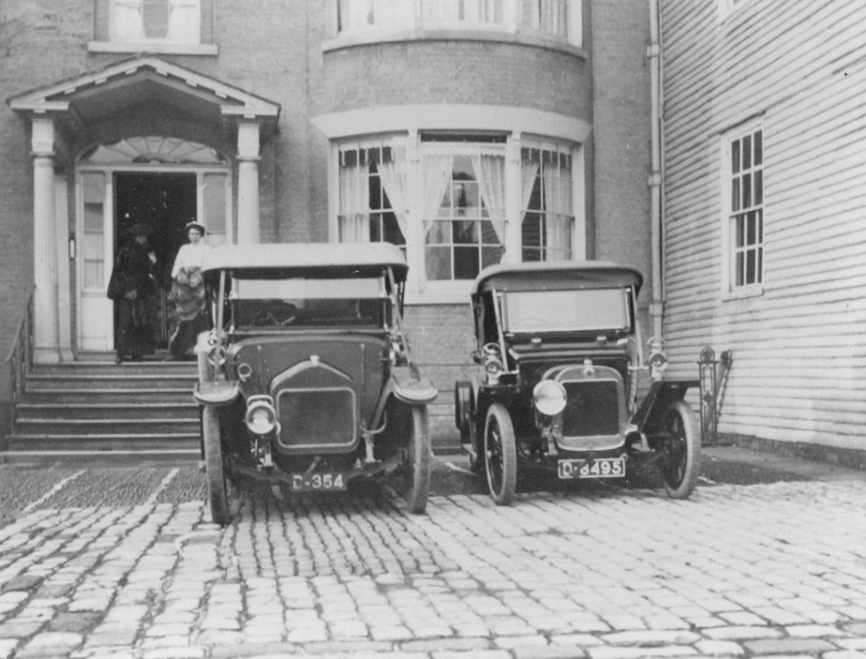

This is one of the photos from Hilary Harding's collection. It is a copy, but Hilary has written 1911 on the back. The car registrations are D354 and D8495. I have been going through the Register of Vehicles at the Kent History and Library Centre off and on (C/FL/1/1/2 covers D1 1903 to D956 1904 for example). D354 appears 4 times so I am not sure which car is in the photo - any veteran car experts please take a look! It could be either of the last two.
D354 Herbert John Ward, Mill House Farningham
Wolseley (red 7½ hp) 28/12/1903
Humber (dark green 10-12 hp) 21/8/1906 cancelled 21/5/1909
Siddeley (tonneau dark blue red lined 14hp) 21/5/1908 cancelled 28/5/1911
Wolseley (torpedo-phaeton grey-green lines 16hp) 28/5/1911 cancelled 26/11/1920

and finally…..
As I write this I am looking out my window at a beautiful blue sky and snow-covered roofs. I hope you enjoy this old photograph of Eynsford dealing with the snow probably about 100 years ago. Look no gloves …… (photograph from James Alexander Collection (Old Eynsford)
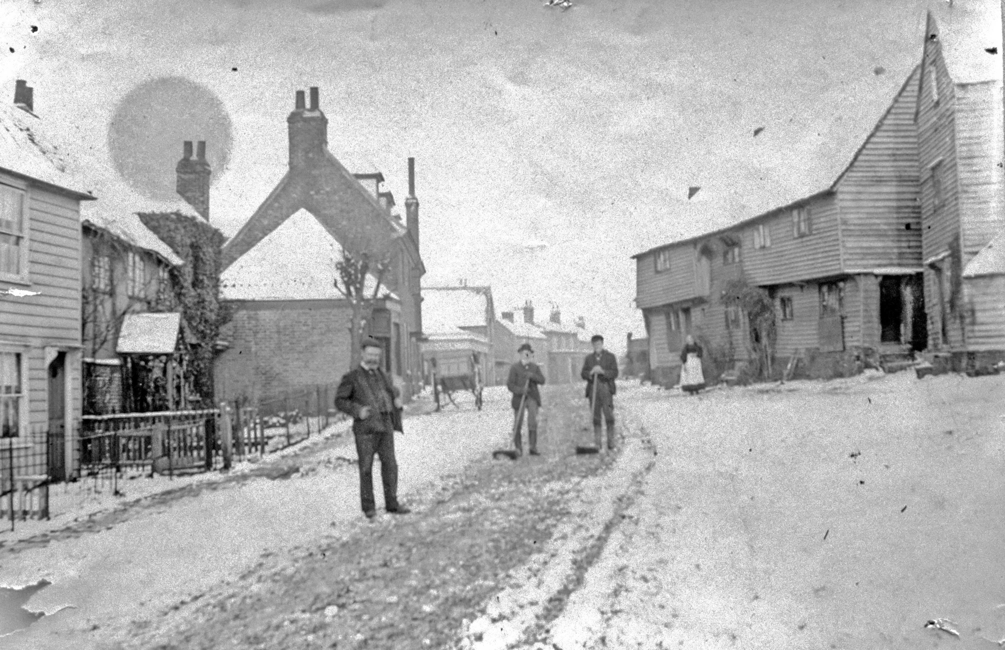

Jan Wilkes - Editor



What’s On 2018

Horton Kirby & South Darenth Local History Society

12th March Kent and East Sussex Railway -Then and Now - Doug Lindsay
14th May Life and Times of Edith Cavell - Melanie Gibson-Barton
9th July 1917 - Bombs on Kent – Alex Ferris
10th September Development of South Darenth before 1900 – Malcolm Scott
12th November AGM + short talk + wine and cheese
Meetings are held on Monday at the Village Hall, South Darenth from 8pm. If you require further information, contact Barbara Cannell (01322 864253) (Remember your membership card)

Shoreham History Society

16th March The Medieval Housewife – Toni Mount
Meetings held in the Village Hall Shoreham from 8pm. Members who wish to attend these meetings are advised to contact the Secretary Lynda Alleeson (01959 525312) to check that no changes have been made to their programmes (Remember your membership card)

Hextable

8th March Lost Empires – The Last Days of Music Hall and Variety –
Wilf Lower
12th April The Forming of the RAF and the early days of Biggin Hill –
Bob Ogly
10th May AGM followed by The Winchester Mystery House – Sharron
Mitchell
14th June Seaside Postcards – Alan Payne
12th July Evening Visit Firefighting Museum – Woodlands Garden
Centre, Ash (time to be confirmed)
9th August Alexander Pitcairn – The Body in the Church – Jan Wilkes
13th September Pocahontas – without Disney – Christoph Bull
11th October Guy Fawkes – Anne Carter
8th November South Darenth and Sink the Link – Sarah Lewis
6th December Christmas Party – A History of Teddies and Other Bears –
Melanie Gibson-Barton
Meetings are held at the Hextable Heritage Centre. Crawfords, Dawson Drive, College Road, Hextable from 7.30pm. If you require further information, please contact Barbara Cannell (01322 864253) (Remember your membership card)

