The Farningham & Eynsford Local History Society
(Original Society founded 1985 Registered Charity no 1047562)
A Charitable Company Limited by Guarantee
No. 5620267 incorporated 11th November 2005 Registered Charity 1113765
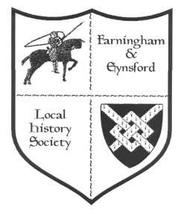
Bulletin No 119
Autumn 2018

Forthcoming Talks and Events for 2019

2019 Doors open at 7.30 pm for talks at 8.00 pm. There are displays of items from the FELHS collection and light refreshments. (Helen Smith 01322 864234)
********************************************************************
15 February Eynsford Village Hall
The history and origins of Nursery Rhymes talk and short quiz by Dr John Reuther (counting songs, nonsense rhymes, historical lampoons, lullabies)
16 February Farningham Village Hall
EXHIBITION 11am - 4 pm: Farningham Shops and Shopping
A second chance to see this popular exhibition in more spacious surrounds
22 March Eynsford Village Hall
Mills of the Darent Valley by Dr Lionel Parks (a trip down the river for the origins and sites of various water mills which once lined the banks)
26 April Farningham Village Hall
Some Kent ghosts by Dennis Chambers (learn how Kent is at the top of the league of the most haunted counties)
31 May Eynsford Village Hall
AGM - with a display of photos from the Anthony Roper School archive
20 September Farningham Village Hall
Dirty Dartford by Christoph Bull (discover how Dartford has shaped the very world in which we live)
8 November Eynsford Village Hall
Creep, pull, push - workers on the move by Dr Jean Stirk (the willing or unwilling motives behind the moves and how to trace moving families)
6 December Farningham Village Hall
Films from FELHS collection (details to be announced)
FARNINGHAM & EYNSFORD LOCAL HISTORY CENTRE
Between Riverside Social Club & Eynsford Cricket Meadow, Riverside DA4 0AE
Open: Monday 9.30 am - noon (March-November) - and by appointment through the year.
Enquiries via archives@felhs.org.uk website: www.felhs.org.uk
Come along, or contact us if you have a query. Items (photos, documents, objects, memories, information) can be shared with us. We are adding to the collection all the time, and can copy precious items if you prefer to hold on to the originals.

CHAIRMAN'S REPORT (Veronica Sheppard)
I am glad to report that it has not been necessary for the Society to close this year, and we have a full programme for the next. We still need help with the various tasks, as outlined further on in the Bulletin. However, since our last appeal we are delighted to welcome Pat Dee, who has joined the volunteers on Monday mornings, and Ann Cornwell, a stalwart Monday morning helper, who has now agreed to join the committee.
I was sorry to have missed the very popular September meeting when a film about life in Eynsford during the 2nd World War, shot by Norah Penwarden, was shown. I understand there was a record attendance with over 60 visitors and 30 members. Susan's power-point presentation about Farningham and Eynsford's peace celebrations following the First World War and general life in the villages in the 1920s also attracted a wide attendance with many visitors welcomed. Noteworthy was the attendance of Irene Whittaker, aged 100, and a member's daughter aged about 10 - a ninety year age span! We congratulate Vikki Saunders on the fascinating and informative exhibition she researched about the shops in Farningham. This was held in the new Shand Hall, which was packed throughout the day - nearly 200 people, including family groups coming in to see the display. So popular was it that there were many requests to put the exhibition on again - perhaps in the Village Hall.
We will take a break for the winter in mid-November at the Centre, partly because Christmas and New Year's activities crowd in, but also it becomes too cold there. The Centre will open again in March, but is always available by appointment. I would like to extend a big thank-you to James Alexander for allowing us access to his father's slides. The first batch of twenty-one boxes covering Eynsford from 1960 to 1990 has now been catalogued, but there are many more boxes to be done - an ongoing project for next year, and more Monday morning fun, you are welcome to join.
2019 will be a very full year with more meetings than ever - the first meeting of the Spring series taking place in February.
Your membership is very important to us and we appreciate the support you give. Subscription time is upon us once more. Please continue to support the Society, the members are very important, you are why we continue to strive towards gaining more knowledge of our local communities throughout the ages. Details are in the Membership Secretary's report with Membership form for annual members being sent round with this Bulletin.
I am sure you have met Irene Whittaker over the years. She was one of the Society's first members and reached the grand age of 100 on the 18th October. Congratulations in the form of a card were sent from FELHS. Once more we wish her well and hope to see her at the next meeting.
Christmas and New Year are around the corner - Have a good time and see you in 2019.

MEMBERSHIP SECRETARY (Alison Marshall 01322 862298)
- With this issue of the Bulletin comes the reminder to annual members to renew subscriptions. You will find a renewal form attached or enclosed, depending on your preference.
- When you complete the form please do sign the Gift Aid section if you are a tax payer because it helps the Society by making your subscription more valuable.
- Please return all completed forms to me either by post or by putting it through the door at 11a Riverside, Eynsford, Kent DA4 0AE - it is on the track to the Cricket Meadow.
- You can now find bank account details on the form if you prefer to pay by bank transfer, or otherwise please include your cheque or cash in the envelope with your form.

Volunteering opportunities: (contact details for Helen Smith or Susan Pittman in Bulletin)
We still require more help to spread the load all of us are coping with. We act as a team and would welcome newcomers - all offers gratefully received
Meetings secretary (to help run the current programme & plan for the future)
Bulletin editor (to compile the Bulletin - computer skills required)
Publications manager (sending out FELHS publications on request)
We also need more casual help
- with refreshments and setting up venue for meetings
- with distribution of the Bulletin
- inputting Trident index onto computer
- with keeping the Farningham Scrap Book up to date (newspaper cuttings provided)
- joining the Monday morning team at the Centre

RESEARCH REPORT (Susan Pittman 01322 669923 www.felhs.org.uk)
New books for Christmas:
The Commemoration of Wars in Crockenhill, Eynsford and Lullingstone
This FELHS publication has been re-printed with some amendments, and is updated to include recent burials from the war in Afghanistan. £5 + £1.50pp - contact above or through Publications page on website.
Swanley War Memorial, The First World War - The stories behind the names
110 men are listed among the dead from the First World War. These men came from 'Swanley District' so included many from outside Swanley town itself. Several came from Crockenhill, and are also commemorated in All Souls' Church. Many came from the parish of Farningham, the boundary of which in those days covered a large area of east Swanley up to the present Co-op Garage. The book is well produced and covers more than the stories behind the names. It opens with the background of how money for the monument was raised, its sculptor and a description of the monument itself. It moves on to the opening ceremony, before discussing the medals awarded during the war. However, the bulk of the book concentrates on the individuals who died in the war. It is well worth adding it to the bookshelf.
Published by Swanley History Group, £8 if collected at meetings of the Group, £11.50 (includes post and packaging) payable by cheque or crossed postal order from Ann Holland, 5 Victoria Hill Road, Hextable BR8 7LL.
The Miller Family - Farmers at Wested Farm, Crockenhill
This is my latest publication covering the history of the farming family founded by Moses Miller, who became a lavender and peppermint grower in Mitcham, and then expanded to Court Lodge Farm, Chelsfield (where his descendants still live), and Wested Farm, Crockenhill. At one time Wested Farm was the largest producer of peppermint in the U.K. The book traces the rise of the Miller family, through to the diversification brought about by the import of cheaper peppermint, and the difficulty in finding a new role for the farm, until sold by the Miller family in the 1990s.
£8 (£9.50 included post and packaging) from Crockenhill Parish Council, Crockenhill Village Hall, Stones Cross Road, Crockenhill BR8 8LT or myself 27 Old Chapel Road, Crockenhill BR8 8LL.

Dartford Union Settlement Records
These are loose papers, not individually catalogued. They contain a wealth of information for the family historian:
- Marianne Wellard (58) - In 1909 Marianne was single, a lunatic received into Bexley Asylum. Her settlement was in Farningham, where she had lived at various addresses. For 2 years she lived with Mr Cornell at 5 Carlton Villas, until he left to find another job as an engineer, when the lease of Mr Moore's flour mill ended. Then she lived with her cousin, Mrs Rebecca Wallace of Farningham, until she became sick. Next she went to her sister, Mrs Eleanor Debenham, at Clapham, followed by a move to another sister, Mrs Mason of Eynsford. Yet another move followed in 1893 when she went to live with her widowed mother, Anne Wellard at Mrs Lewis, South Terrace, Farningham. After her mother's death in 1897, she finally moved in with Mrs Crowhurst at High Street, Farningham.
G/Da/AS/3 - Settlement Record
- Florence Abbott (10) - Florence had a sister (4) and brother (9) in Wandsworth and Clapham Workhouse. They were the children of Herbert Abbott (34), a qualified chemist, who had separated from his wife. Mrs Nellie Marr of Great Wested Farm had looked after Florence, her niece, from 1900, with her father paying five shillings a week for her upkeep. On 17 March 1902 Mrs Marr received a letter from Florence's father saying that he was going abroad and hoped never to return. His wife's immorality had caused him great distress and at times he had been suicidal. His health had been undermined, forcing him to leave his job after seven years. He left the address of his wife, then living in Birmingham. Florence was refused settlement within the Dartford Union area, so presumably she was sent to join her siblings in Wandsworth and Clapham Workhouse.
G/Da/AS/5 (A-C) - Settlement Record
- George Mills (75) - In 1902 George was removed from Lambeth because his settlement was in Farningham. He had lived and worked at Chimham's for 30 years, but had left about 7 years previously, after the death of his wife.
G/Da/AS/5 (L-M) - Settlement Record
- Elizabeth Payne - In 1903 she lived at 98 Westview, Crockenhill, was a widow and blind. She and her husband had lived in Deptford where her husband had worked for London County Council as a flusher of sewers. After 19 years he had become ill and was discharged. The couple came to live in Crockenhill where she had been left destitute after her husband's death on 6 February 1903.
G/Da/AS/5 (N-Z) - Settlement Record
- Bertha Inkpen (30) - Bertha was born in Tonbridge on 12 April 1876, the daughter of John and Sophia, who had married in Hartfield in 1867. Bertha had gained settlement in Longfield where she had worked from 1897 to 1901. She then worked in Shorne, until becoming a kitchen maid at Franks Hall, Farningham. After this post she had wandered from household to household until March 1906, when she entered Sevenoaks Union Workhouse pregnant.
G/Da/AS/7 - Settlement Record

Three headmasters during the First World War
- Samuel Woolley: Veteran Eynsford Schoolmaster retires, 1914
Samuel Woolley had been teaching in Eynsford for nearly 40 years. He had acted as head of the British School (Non-Conformist) before transferring to the Board (Council) School in the late 1880s. He was intending to continue to live in Eynsford. 500 people assembled in the Drill Hall (Village Hall) for a farewell concert. During the evening Mr Woolley was presented with an album and address of esteem for his past services, together with a testimonial of £50.
In the event, Mr Woolley did not retire until the end of the First World War, because the newly appointed head, Mr Hillier volunteered to join the armed forces.
(St Mary Cray and Orpington District Times, 30/1/1914, 6/3/1914)
- Leslie Reginald Hillier 1881-c.1964
Leslie Hillier replaced Samuel Woolley months before the outbreak of war. During his war service he found himself in a particularly dangerous situation in the Holy Land, and pledged, that if he survived he would devote the rest of his life to the training of boys. On his return to teaching he revived the Scout Troop in Eynsford, becoming the Scout Master. He organised a training evening on Mondays and physical activities mid-week. On Saturdays he arranged paper chases or team games. The first post-war Scout camp was in 1921 when the Scouts walked 15 miles to Brasted pulling a trek-cart with them. As well as being Scout Master, he organised after-school activities for his pupils - cricket, football, and school plays and concerts. While at Eynsford he lodged with Mr and Mrs Friend near the Village Hall - Mr Friend being Sir Henry and Lady Fountain's gardener
at Little Mote. In retirement he went to live with his sister in Broadstone, Dorset.
(Letter at the Centre 2/7/1979, Bill Martin to Bill Parker)
- John Whitfield Hetherington (1881-1959), headmaster of Farningham Church of England School
Dave from the Aliens Rugby Club in Liverpool, of which John Hetherington was a founder member, wanted to know whether he had served in the First World War. As I had come across John Hetherington during my research for The Great War at Home Exhibition I was able to send evidence that he did not serve in the War, but was transferred from headship of Farningham School to the headship of Sutton-at-Hone Boys School for the duration. I could find no evidence that he was linked with Rugby locally, although an article on his retirement in 1940 stated that he had been secretary of Farningham Tennis Club and Farningham Cricket Club. Dave sent us a copy of his Teacher's Registration form and a photograph of Hetherington.

R.E.G. Brown, Motor Transport Contractor, Eynsford
Reg Brown was from the Brown family who farmed at Pedham Place. In 1922 he bought a Hallford lorry, locally built in Dartford, and soon found work for it among the local farming community and merchants supplying to them. By 1938 he had purchased his 25th vehicle, and had established a depot in Priory Lane, Eynsford. In 1949 the Brown fleet was taken over by the Road Haulage Executive, becoming part of British Road Services, which is where this article breaks off.
(Vintage Roadscene June 2018, article p.10-13 by Allan Bedford) (Photo at end of Bulletin)

Robert George William Rolph MBE, 1919-1984
Robert grew up in the Waterworks at Eynsford. He was called up at the outbreak of the Second World War and served with the Royal Electrical and Mechanical Engineers, spending time both in North Africa and Italy. While in REME he invented a method of waterproofing the electrical system of army tanks so that they could travel through water. For this innovation he was awarded an MBE in 1947. After the war he became a teacher, rising to the headship of Horton Kirby Primary School.
(Information from Liz Rolph, his daughter-in-law, who allowed us to copy items from a collection she has about her father-in-law)

Police Houses, Station Road, Eynsford
This item has been contributed by David Smith, whom we were pleased to welcome to the Centre recently to look through the photograph collection. If this sparks other memories I would be happy to receive them:-
There was a time, not so long ago, that virtually every village in Kent had one or two Village Bobbies, who lived in a Police House in the village, with an office attached. Eynsford had two such Police Houses in Station Road, Eynsford. These were named, in accordance with usual practice, as 1 Police House and 2 Police House.
I was privileged to serve as a PC in Eynsford, living at 1 Police House. I moved there in 1974. My neighbour, at 2 Police House, was PC Bob Funnell. We were both responsible for Eynsford and Farningham. I was promoted to Sergeant in 1976 and worked from Swanley, but I continued to live at the Police House in Eynsford until 1986 when I moved to Rochester.
I really enjoyed my time in Eynsford. My children all went to Anthony Roper Primary School, and I ran the Cub Scout Pack for several years. I have fond memories of my time at Eynsford, and of many residents, including Mick Williams and Nora Duncan.
About 1977 a Police Officer living in another part of Kent requested that the name of the police house in which he lived be changed from Police House to another name. This was so that, when dealing with companies etc., his occupation would not be evident. (I never found that this caused me any concern.) The Chief Constable agreed and decided that all such houses would be re-named. The Divisional Commanders were required to make arrangements for this. The majority of police houses were re-named Kent House and Invicta House.
However, the Divisional Commander for Gravesend, Dartford and Swanley decided that the houses should be re-named to reflect the occupant or locality. My surname is Smith and so he re-named 1 Police House to Anvil House, for obvious reasons. He re-named 2, Police House to Stack House to reflect that the occupier was Bob Funnell (a ship’s funnel is also called the stack).
I recently visited Eynsford and went to look at my old house. Stack House has been extended and clad in wood and is unrecognisable as the original house. I saw that Anvil House and the Police Office had been demolished and two modern houses built in their place. It was pleasing to see that one of these is still named Anvil House. It is nice to feel that I am, in a very minor way, part of the history of Eynsford.
The Police House at West Kingsdown was re-named Brandscop (from Brands Hatch and copper). The Police House at Crockenhill was re-named Leeville (after Jack Waterton-Lee, a County Councillor and member of the Police Authority, who lived nearby). I am not sure that the PC who lived at the Horton Kirby Police House was very pleased when his house was re-named Resthaven!

General enquiries
Percy Pilcher - Susan asked us to provide information. I supplied her with the Percy Pilcher section of our catalogue
Moisant crash at St Clere, Kemsing - On a visit with the Kent Gardens Trust we were told that the early plane crash in 1910 involved Bleriot. However, it was Moisant whose plane crashed. I sent information with fuller details than the estate manager had previously seen. If you wish to learn more www.kemsingheritagecentre.org.uk has further information.
Anthony Roper's will of 1597 - John was trying to track down a copy to authenticate a signature he had found on another document. I found the National Archives reference, but in the end he found the signature on document U1590/T11/9 at the Kent History and Library Centre.
Impact of land use on flooding in Eynsford - Emelye required information for her A- Level
Geography studies. I gave her some pointers and invited her to the Centre to study our
photographs of floods, but she did not follow this up.
'A City set on a Hill' by Patrick Roast - Patrick's son, Philip, is thinking of republishing the book about Farningham Home for Little Boys with updates and revisions. If you are interested in obtaining a copy in due course, let me know, or contact him through the 'Noticeboard' page of our website.
Celebrating 100 years of Women's Achievements - In May the District Council sent a letter to say it was thinking of planning an event in the week beginning 12 November to draw attention to the achievements of women in the Sevenoaks area since 1918, when women were allowed to stand as candidates and be elected as MPs. Unfortunately, this coincided with the 100th anniversary of the 1918 Armistice celebrations, to which we were already committed. I did, however, put forward the names of Jessica Albery, a pioneering architect, and Lady Zoe Hart Dyke, an entrepreneur. Women farm workers in the First World War - Hilary, the Old Chalk New Downs Project Outreach Officer, wanted information and pictures of the Women's Land Army in the First World War. I could not find any local references because women were already working on the land, so did longer hours; children, a few months before reaching 14, were allowed to leave school early to work on the land; and seasonal workers came from London.
Sevenoaks Railway - Swanley Junction to Bat and Ball - Steve is researching the construction and socio-economic effects of its completion. He wanted to know what our collection held on the subject. I supplied him with the railway section of our catalogue and suggested he contact Ed Thompson, who has long undertaken research on local railways.
Pedham Place and Fort Farningham - Farningham Parish Council wanted information about these sites in relation to the Sevenoaks Draft Plan. Copies of inspectors' reports re applications for Motorway Service Stations were among the items FELHS hold.
Malt Cottage, Eynsford - Steve is currently studying crooked chimney stacks and had seen the sketch of Malt Cottage on our website. I sent him photos. He would be interested in other examples.
Eynsford and Farningham Church Records - Rev. Gary Owen enquired about the whereabouts of records before 1990. I sent a list of the items we hold, but the official records of both churches were sent by previous incumbents to the Kent History and Library Centre, Maidstone.
Family history enquiries
Monty Hever - Allan who has already produced articles on Harber lorries and Brown's haulage business in Priory Lane, is now researching Monty Hever and Darenth Hire Company. He asked me for the life dates of Monty, but they were not in the local registers. In the end he discovered that Monty was born in Eynsford in 1896 and died at Bridge, near Canterbury in 1970.
Walter Wellard - There is a plaque in St Martin's Church to Walter Wellard, son of John and Mary Wellard, who died in Ballarat, Australia on 15 July 1854, aged 26. John wanted to know who put up the plaque, when and why it is there, but I was unable to help. It is possible that Walter was caught up in the Gold Rush in Australia at that time. An inquest held in Melbourne found that he died of natural causes, but condemned the 'undue administration of drugs' by an unqualified medical practitioner.
Alfred Cecil Gee (1803-1872) - John came across his grave in the English Cemetery at Malaga. He died at Benalmedena on 26 December 1872. The headstone gave his date of birth as 18 March 1803 in Eynsford, but he is not entered in the Baptism Register up to 1812, neither is there a Gee family in the censuses of 1841 and 1851. The English Cemetery at Malaga was founded in 1830 for Protestants burials. Before then the Spanish authorities only allowed Protestants to be buried in an upright position at night in an unwholesome spot on the beach. John notes that William Penrose Mark, son of the founder of the Cemetery, died of typhoid fever in 1872, and wonders whether Alfred Cecil Gee succumbed to the same illness. (The English Cemetery at Malaga by Marjorie Grice-Hutchinson, 1982)
Palmer of Mussenden Farm, Horton Kirby - Martin came across a reference from a 2004
Bulletin in which Suzannah enquired about the family! Although a decade or more ago, I tried to
put the two in touch with each other. He said they were likely to be fourth cousins.

ARCHIVE REPORT (Susan Pittman - 01322 6699233 www.felhs.org.uk)
Our team at the Centre has been working hard, but happily, on several tasks. Helen, assisted by Ann, Veronica or Alison, has been inputting the captions from James Alexander's slide collection into a digital catalogue. The 21 boxes catalogued comprise scenes of Eynsford from the 1970s to the 1990s. We are most grateful to James for sorting out the boxes because the images mean so much more if they can be coupled with the captions. Vikki has been researching Farningham shops for the Exhibition in November, and has found some fascinating material. Veronica has helped me with checking the contents of the folders against the catalogue, and being adaptable at other times when other tasks needed doing. Ann has also taken on the Farningham Scrapbook (until a Farningham volunteer is found). After our appeal in the Summer Bulletin we have welcomed Pat from Eynsford, who has been thrown in the deep-end, but not been put off!
We have had yet more water problems - a leaking water heater, and a leak overhead in the office. A central heating engineer came to look at the water heater, but all the internal fittings had seized up, so the whole unit was removed. Repairing the overhead leak will be more tricky. Helen's husband, Barry, had a look in the attic, but it has a false ceiling so there is only crawling room, also the pipe rests directly on the joists so it has proved impossible to discover the source of the leak. Now water is not being constantly drawn to the water heater, the leak has become less obvious, but it can't have gone away - Any friendly plumbers out there???
A super hit-for-six from the Cricket pitch has damaged a roof tile, and we await the Cricket Club to do a repair - apparently sourcing a matching tile has been a problem.

Acquisitions
From Barbara Cannell - King's England by Arthur Mee (London, Kent, Sussex, Surrey); Maps for the Local Historian by J.B. Harley; Writing Local History by David Dymond; Fordwich by K.N. McIntosh.
From D. Humphrey - 2 photos of R.E.G. Brown lorries, 1930s & 1940s, with names of drivers.
From Jan Wilkes - 4 Axstane Players programmes 2015-2017.

From the collection - Licence for Armorial Bearings, Male Servants, and Dogs
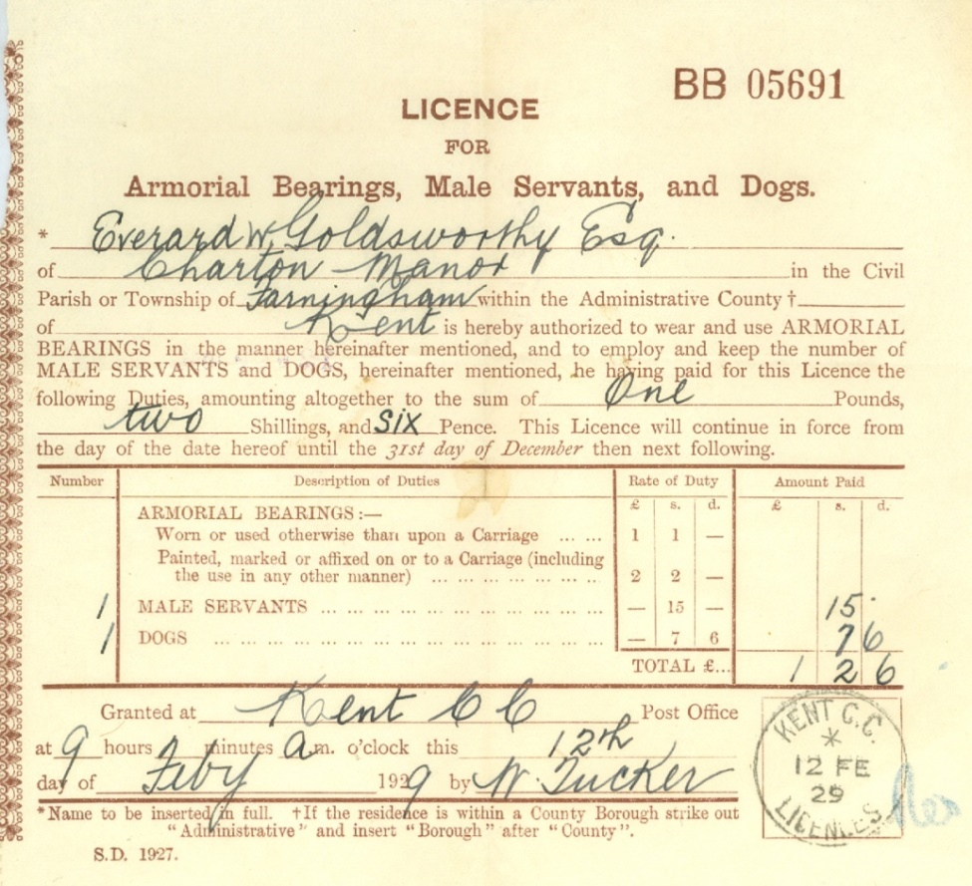
We came across this item the other day and although it amused us, it gave us pause to think.
The juxtaposition of male servants and dogs shocked us, as did the low value of the male servant implied by the cost of two dog licences being the same as for one male servant. Another surprise was that a licence for a male servant was required anyway, and certainly as late as 1929. It seemed more akin to the Middle Ages.
The duty from the licence was a local tax in England and Wales, and its administration rested with the county councils and county borough councils which received the proceeds. The licence was introduced in the budget of 1869, and was repealed in the Finance Act of 1937.
What’s On Elsewhere in 2019
Members of FELHS can attend free of charge if they bring proof of membership, e.g. email or other receipt of subs, or life membership card.
Horton Kirby & South Darenth Local History Society http://hksdhs.org.uk (& on Facebook)
14 January Woolwich Women at War -Steve Hookins
11 March The Romance of London's River - Tony Farnham
20 May The Kaiser's War - Christoph Bull
Meetings are held on Monday at the Village Hall, South Darenth from 8pm.
For further information, contact Barbara Cannell (01322 864253)
Shoreham & District Historical Society www.shorehamkenthistorical.org.uk
16 November (2018) Brick Making - David Cufley
18 January (2019) The Dr Lothian Lecture - John Keates FRCS
15 February The Medway Queen
15 March AGM - Kentish Libraries by Christoph Bull
19 April Knole (Vita Sackville and Harold Nicolson) - Marcia Barton
Meetings are held in the Village Hall Shoreham from 8pm. Members who wish to attend these meetings are advised to contact the Secretary Lynda Alleeson (01959 525312) to check that no changes have been made to their programmes
Hextable Heritage Society www.hextable-heritage.co.uk (& on Facebook)
8 November (2018) South Darenth and Sink the Link – Sarah Lewis
6 December Christmas Party – A History of Teddies and Other Bears –
Melanie Gibson-Barton
Meetings are held at the Hextable Heritage Centre, Crawfords, Dawson Drive, College Road, Hextable from 7.30pm. For further information, please contact Barbara Cannell (01322 864253)

