The Farningham & Eynsford Local History Society
(Original Society founded 1985 Registered Charity no 1047562)
A Charitable Company Limited by Guarantee
No. 5620267 incorporated 11th November 2005 Registered Charity 1113765
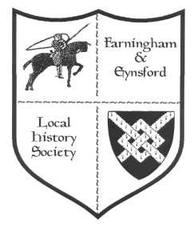
Bulletin No. 120
Spring 2019

NOTICE OF ANNUAL GENERAL MEETING 2019
The AGM will take place at Eynsford Village Hall on Friday 31 May
at 8.00 pm (doors open 7.30 pm).

BEFORE and AFTER THE AGM
Browse through the Anthony Roper School photographic collection
from its foundation in the 1970s into the C21st

AGM AGENDA
1. Welcome
2. Apologies for absence
3. Minutes of 2018 AGM & acceptance
4. Matters arising
5. Adoption of Accounts
6. Setting of Subscription Level for 2020
7. Chairman's Report & supporting reports
8. Election of Officers and Committee (new nominations welcome)
9. Election of Directors
10. Any other business

We have co-opted two new Committee members since the last AGM, but are still under strength. Please contact a Committee member if you are interested in finding out what is involved: (Contact details for Alison Marshall, Susan Pittman, or Helen Smith in Bulletin)
We act as a team and would welcome newcomers - all offers gratefully received. Required -
Bulletin editor (to compile the Bulletin - computer skills required)
Publications manager (sending out FELHS publications on request)
We also need more casual help with refreshments and setting up venue for meetings; distribution of the Bulletin; putting Trident index onto computer; keeping the Farningham Scrap Book up to date (newspaper cuttings provided); joining the Monday morning team at the Centre.

2019 - FORTHCOMING TALKS AND EVENTS

2019 Doors open at 7.30 pm for talks at 8.00 pm. There are displays of items from the FELHS collection and light refreshments. (Helen Smith 01322 864234)
********************************************************************
26 April Farningham Village Hall
Some Kent ghosts by Dennis Chambers (learn how Kent is at the top of the league of the most haunted counties)
31 May Eynsford Village Hall
AGM - with a display of photos from the Anthony Roper School archive
20 September Farningham Village Hall
Dirty Dartford by Christoph Bull (discover how Dartford has shaped the very world in which we live)
8 November Eynsford Village Hall
Creep, pull, push - workers on the move by Dr Jean Stirk (the willing or unwilling motives behind the moves and how to trace moving families)
6 December Farningham Village Hall
Films from FELHS collection (details to be announced)
FARNINGHAM & EYNSFORD LOCAL HISTORY CENTRE
Between Riverside Social Club & Eynsford Cricket Meadow, Riverside DA4 0AE
Open: Monday 9.30 am - noon (from 11 March-November) - and by appointment through the year.
Enquiries via archives@felhs.org.uk website: www.felhs.org.uk
Come along to visit or to help, or contact us if you have a query. Items (photos, documents, objects, memories, information) can be shared with us. We are adding to the collection all the time, and can copy precious items if you prefer to hold on to the originals.

CHAIRMAN'S REPORT (Veronica Sheppard)
We are well into the New Year and our first talk, 'Nursery Rhymes', in February proved to be both instructive and amusing. Most people assume Humpty Dumpty first appeared in Lewis Carroll's 'Alice through the Looking Glass' (1871), but was a common nickname used in 15th century England for very large people. On Saturday 16th February we had the second showing of the very popular exhibition of 'Farningham Shops', which was attended by more than one hundred visitors, several of whom lingered for hours and fortuitously bumped into friends not seen for years. Once more we congratulate Vikki Saunders for putting together a splendid show, with a little help from the rest of the Committee.
By the time you receive this, the March talk on 'Water Mills of Darent Valley' by Dr. Lionel Parks will have passed, and we wait to be frightened by Dennis Chambers' talk on 'Some Kent Ghosts' in April.
We were delighted to co-opt Pat Dee onto the Committee in January. She has agreed to be our Events Secretary, and has already begun to arrange the 2020 programme for the Society. Her help will be much appreciated and we thank her for taking on this role. She is also a Monday volunteer at the Centre - the new season of which began on 11 March.
AN IMPORTANT REMINDER OF THE AGM on 31 MAY - with two more Committee members co-opted since the last AGM, tasks are becoming more manageable, but we would love to welcome more volunteers on to the Committee or for help in general.
Easter (pascula) is nearly here. The British Isles are rich with traditions, especially around Easter. Egg Jarping is one of them. In the North East of England Egg Jarping is the simple matter of bashing one hard-boiled egg on another egg to see which one stays intact. There's even a World Jarping Championship in Peterlee, Durham!!! In the picturesque Kent village of Biddenden cakes, with the figures of two women impressed on them, are distributed every year on Easter Monday. Local tradition records that the benefactors were conjoined twins, Eliza and Mary Chalkhurst, who died in 1134 at the age of 34. They gave twenty acres of land, now known as Bread and Cheese Lands, to raise money for cakes for the poor. Even when the charity’s Bread and Cheese Lands were sold for housing the custom survived, and the profit meant that not only are bread, cheese and tea provided, but cash payments are made at Christmas as well.
MEMBERSHIP SECRETARY (Alison Marshall 01322 862298)
- With this issue of the Bulletin comes the reminder to annual members, who have not already done so, to renew subscriptions. You will find a renewal form attached or enclosed, depending on your preference.
- When you complete the form please do sign the Gift Aid section if you are a tax payer because it helps the Society by making your subscription more valuable.
- Please return all completed forms to me either by post or by putting it through the door at 11a Riverside, Eynsford, Kent DA4 0AE - it is on the track to the Cricket Meadow.
- You can now find bank account details on the form if you prefer to pay by bank transfer, or otherwise please include your cheque or cash in the envelope with your form.

RESEARCH REPORT (Susan Pittman 01322 669923 www.felhs.org.uk)

Formation of Eynsford (1919) and Farningham W.I.s (1918)
At the November meeting I showed a photo of a W.I. gathering in 1938 on a stage, with several ladies wearing sashes '1917-1938', and a celebration cake displayed. The photo in our collection had no details on it, and (because of the size of the stage) I wrongly assumed this to be a photo of Eynsford W.I. I therefore did not check FELHS publication 8. 'Eynsford Women's Institute - the first 75 years', by Diana Beamish. She pointed out after the talk that Eynsford W.I. was founded on 21 May 1919. Reg Nightingale's FELHS publication no.27, 'Brief Histories of Associations .. etc' stated that Farningham W.I. was founded in 1917, but Diana told me that it had celebrated its 100th Anniversary in 2018! I then contacted Marilyn Wells of the Farningham W.I. and shared the photo with her. She recognised two Farningham ladies, Mrs Wilson and Mrs Grey, in the group, but confirmed that Farningham W.I. was registered with the national organisation on 6 June 1918, although it might have held meetings before that. Marilyn's educated guess is that the photo is of the West Kent Annual Meeting held each March in Maidstone, and that the ladies with sashes came from another W.I. in the West Kent area.

New publication - 'Sevenoaks a past to treasure' by Philip Clucas & Ed Thompson
This colourful book takes a pictorial nostalgic look at the town and its surrounds. It is beautifully presented and the photos are well captioned. There is a short introduction to each of the twelve sections, but the pages are mostly filled with images. It is published by Hopgarden Press ISBN 978-0-9956479-3-0, available from Sevenoaks Bookshop at £10.

Audrey Brenda Lucas (nee Baldock) 1917-2013
Audrey's son, Robin, who still lives in Farningham, has put together an album of her life up to her marriage, although the opening pages outline her whole life; with involvement in music at Farningham Primary School, music shows for the W.I., and numerous shows for the Axstane Players, of which she was a founder member in 1967. Her grandfather was papermaker Samuel James Hussey, who moved with his family from Alton to Eynsford, and lived in Bank house terrace opposite Mill Lane. Audrey's other grandfather came from Mayfield, Sussex, and lived in 2 Albert Cottages, opposite the war memorial. Audrey's father helped his father, both carpenters, construct and erect the lych-gate at Eynsford church. Audrey's parents met through singing in the Chapel choir. Her parents' nurtured Audrey's musical talent and she acted as accompanist or taught piano as a career. In the 2nd World War she organised 'Cheery Children's Concerts' in Farningham. She met her husband, Gerald Stanley Lucas, in the war because, as an RAF radio engineer, he was billeted with the Baldock family.
(See Acquisitions below)

Alfred Cecil Gee (1803-1872) - update
In the last Bulletin I mentioned Alfred's grave in the English Cemetery at Malaga. It appears that John, who had seen the grave, misread the inscription by a century! The mystery has been solved by Gloria Gee, who sent a photo of the gravestone. The gravestone commemorates Peter Gee's uncle Cib (1903 - 1972). Alfred Cecil Gee was born at River House, Eynsford. He went to South America when he was sixteen, and spent this working life there. He retired to Spain where he lived until his death. Peter and his brother, Donald, attended the funeral. Thank you for all this, Gloria.

Henry James Smith (1932-1990) - follow-up
Henry was fostered in 1935, and his last known local address was Mr Dunmall's house at 49 High Street, Farningham (Bulletin 118). Barbara Cannell pointed out that Mrs Walter Dunmall of High Street, Farningham, was featured in the Kentish Times article on Farningham by a Modern Chronicler in the issue of 30 December, 1938. It would appear from the text that Mrs Dunmall was born a Dunmall. Her father was the parish constable. She went into service, latterly for Dr Thomas Slaughter at Sandhurst, Farningham - his four sons followed medical careers, two as Army doctors, one as a naval doctor, while the fourth became a G.P. Mrs Dunmall's son, Walter, drove the first motor bus from Dartford to Farningham two to three times a day.

Letter from Jean Hynard, aged 92, about Simpson Wilcox
Jean remembers the Wilcox family, from her years with her husband, Gordon, at Lower Austin Lodge. Mr and Mrs Wilcox lived in the upstairs flat of three flats in Lower Austin Lodge farmhouse, which belonged to Jean's father-in-law, Frederick Hynard. Mr and Mrs Wilcox's flat was at the back of the house, comprising a large kitchen with sink and taps, and a fireplace, two bedrooms and a living room. Simpson Wilcox had died by the time Jean came to the farm in 1950, but his wife stayed on with one of her daughters living with her for a while. Mr Wilcox 'Wilkie' looked after the horses, which he harnessed and got into the wagon shafts without any help, which impressed those who saw it. Jean does not know whether Wilkie ploughed with the horses, but he did collect crops from the fields with horse and cart. Crops included sacks of cabbages, boxes of runner beans, and apples and pears. Betty Brown's lorry would collect the produce from the farmyard and take it to Clarke & Joel in Covent Garden. Local potato merchants would collect potatoes themselves from the yard or the loading stage in the barn if it was frosty. Jean remembers Mrs Wilcox, usually wearing black. She worked in the fields, hoeing runner beans and pulling up cabbage seedlings for planting, according to Gordon Hynard's diary, which Jean has kept.

Loftus Edgar Lambourn's unusual will, 1915
My latest research into the Lee farming family of Crockenhill has thrown up interesting correspondence related to Rose Marchant of Hillfield, Farningham, previously of the Old Parsonage. Somehow or other, Sydney Lee of Crockenhill became involved. L. E. Lambourn died in 1932. He lived in Felixstowe, Suffolk, and he left Rose Marchant money accruing from his insurance policies and his deposit in the Post Office Savings Bank. He also left £100 to the building fund of the Adult School in Felixstowe, a legacy not claimed because such a fund was not in existence! This will is very musical. It mentions an American organ, French model double bass, Chappell piano and Ibach piano, a violin, a best viola, 4-string double bass, and band and piano music. Miss Marchant was to be consulted as to whether she would carry on his business (was it musical?) under supervision, with the option at the end of an unspecified period to continue it, or to sell whole or part of it. The period between the date of the will (1915) and L. E. Lambourn's death (1932) might well have caused difficulty. Clearly Miss Marchant was not living in Felixstowe, and wanted nothing to do with the administration of the estate and renounced her rights. To date the link between L. E. Lambourn and Rose Marchant is unknown. Research would no doubt resolve this - at least there can't be too many named Loftus Edgar Lambourn!

Incompetent poachers caught in Chalkhurst Wood, Eynsford, 1891
William Marion, assistant gamekeeper to Sir William Hart Dyke, caught three poachers in 'Chalker's Wood' (sic) on 22 November 1891. One, George Stockdale was observed chasing rabbits with a stick! He ran away, but was caught and found to have nine snares in his clothing. George Clout and Henry Atkins were caught on the same day - Clout with a rabbit. Clout had previously been convicted for being drunk and disorderly, and Atkins for gaming on the highway. Stockdale received a fine of £1 and costs, while Atkins' fine was also £1 and costs or 14 days in prison, and Clout's £1/10s (£1.50p) or 21 days in prison.
(Maidstone & Kentish Journal 8/12/1891)

The Origins of 'Pax', Eynsford, from Norman Howard, nephew to Tom Baldwin
Norman lived in Eynsford with his parents and siblings from the early 1900s. He wrote an undated letter from Canada, and it is unknown when he emigrated. Apparently, his parents and family were the first tenants of 'Pax', which was built by E. D. Till. The house was an experiment to construct a cheap form of house for the working class. The methods/materials used contravened Kent county bye-laws, and Till was faced with a costly law suit. His lawyer was Sir Rufus Isaacs, in 1910 Solicitor General, then Attorney General, in Asquith's government. In 1921 Sir Rufus become Viceroy of India, and in 1926 was created 1st Earl of Reading. Faced with this formidable lawyer, it perhaps comes as no surprise that Till won. After 'Pax' was built Till asked to be invited in to see the house, and he gave Norman's mother a golden sovereign as thanks.
(See acquisitions below. Has anyone got any photos of 'Pax', or know any more about the house?)

General enquiries
Pearmain, Tylers Green, Crockenhill - Gillian from the West Indies, whose mother lived there in 1938, wanted a photo of the house. Gillian's parents moved all over the world, and it is unclear why Crockenhill became home for a short time.
Historical land-use in Darent Valley - Adam wanted information for an A-level Geography assignment. I gave him a list of useful books for him to follow up.
Bridges over the Darent, Lullingstone - Paul asked about the bridge near Lullingstone Roman Villa. I copied him the article by Mildred Hart Dyke about her efforts to replace the bridges demolished by the floods of the 1960s, and images of former bridges on sites which we have been unable to locate.
Ploughing engine photo in 1936 Farningham Exhibition - Edward had seen this photo somewhere in the past, but I could not find one in the collection.
Lone Barn Farm smallholdings - Ann wanted ideas for research into smallholdings created after the 1st World War to provide income and housing for ex-servicemen. In the Lone Barn, Skeet Hill area KCC set up such smallholdings. I suggested 'Arcadia for all - the legacy of a makeshift landscape' by Dennis Hardy and Colin Ward (1984) to lead to other sources.
Eynsford Brass Band - Trevor enquired about the drum in our collection, and wanted dates when the band was active. I found details in Reg Nightingale's FELHS publication no.27. 'Brief Histories of Associations .. etc'. The Band pre-dated 1910 and ceased in about 1940 when members were called up.
Penwarden's garage (Farningham Service Station) - David visited the Centre to share information and photos concerning the employment of his father, Frank Page, at Penwarden's garage from the 1930s. One photo was of Eric Syddique's Rolls Royce. David and his parents lived on the middle floor of the White House, Farningham.
Settlement records - Barbara has looked up Marianne Wellard and George Mills in the 1881 Census, where Marianne's occupation was given as governess. George Mills was an agricultural labourer at Chimham's. (see Bulletin 119). The workhouse records track people's movements, to determine which parish was responsible for upkeep, but they do not generally cover reasons why admittance to a workhouse became necessary. The asylum at Barming (from which the word 'barmy' originates) became Oakwood Hospital, and its records can be found at Kent History and Library Centre, Maidstone under Q/GL 1815-1850, Q/GLr Registers of deaths and discharges 1825-1853, CC/MC1. Asylum minutes 1889-1948, MH/Md2/Ap Patients administration 1833-1963. Access to records after 1918 would be prohibited.

Family history enquiries
Packman - Neil has traced his family back to Henry Packman married Lydia Bird in 1735 - he asked for copies of maps and early images. He also wanted to trace Dyches/Syches cottages. I pointed out that the family was probably based in Crockenhill, where there are Dykes cottages. The family moved to Dartford in the 1830s, before the 1841 Census so I have been unable to link his branch with later Packmans, who stayed in the village until the late C20th.
Palmer & Flewin of Mussenden Farm, Horton Kirby - I passed Barbara's details to previous enquirers, and details of Peter who is interested in the Flewin family.
Turner family - Graham is writing a family history for his father. I was able to show him versions of various Turner trees I hold at home, and lent him the CD of Eynsford Church Registers. The Turner family is vast so he has no easy task ahead.
John Ward, Egyptologist of Farningham - Jannik picked up reference to John Ward from Bulletin No.79 (2008)! Jannik is 3x grandson. He sent family history notes on the Wards, including an obituary for John Ward, and an article on Arthur George Evans (Edith Grace Ward m. Guy Evans) from whom Jannik is descended. He also sent some digital photos from which I will take prints for the Centre. I don't know whether Jannik was able to make contact with previous enquirers, whose details I forwarded to him.
Whiffen - Liz visited the Centre to enquire after the Whiffen men who are listed on Eynsford Baptist Chapel memorial board from the First World War. I found the addresses in Eynsford of Cyril John William Whiffen and George Whiffen junior, but have been unable to trace S. Whiffen, nor whether W. Whiffen actually refers to Cyril J. W. Whiffen.
Whitehead/ Caselton of Crockenhill - Graeme enquired about Philip Whitehead, in 1851 servant in Bath's Stores. I sent him a Victorian image of the shop and a copy of William Whitehead's will of 1758. Castelton is another surname in Graeme's family tree.
Harry Wickenden - Barbara enquired about Harry following a newspaper report of his death in 1943, but this information did not fit in with another Harry, who died in 1948. Both worked at Eynsford Paper Mill.

ARCHIVE REPORT (Susan Pittman - 01322 6699233 www.felhs.org.uk)

The Centre has been closed over winter since the last Bulletin, so except for regular checks, little has been done there. The Centre re-opened on Monday 11 March, and the team has a busy programme ahead. We hope to have another batch of slides from James Alexander's slide collection so that we can input the captions into a digital catalogue. The photographic collection still has to be fully catalogued, and we will be preparing displays for various local events.
Repairing the overhead water leak in the Centre is proving tricky. We have closed off the supply during the winter, and hope to find an agile plumber who can overcome access problems.
A super hit-for-six from the Cricket pitch damaged a roof tile in the summer, and the Cricket Club has at last been repaired, but we await the cricket season with bated breath.

Acquisitions
From Robert Ballard - 4 photos - 2 of the ford at Eynsford in 1976 drought without water; 2 c.1972 of Joe Munn outside his shop, Eynsford.
From Allan Bedford - Vintage Roadscene nos.230 & 231 (Jan & Feb 2019) containing articles by Allan 'Kent Independence' about Monty Hever and Darenth Hire Service. Photo of 1960s Austin bought at Farningham Service Station with its history.
From Emily Crockett - Copies of the deeds of The Nook, High Street, Eynsford - the earliest dated 1799, some surnames over the years - Morgan, Mandy, Holdich, Millbourn, Clark.
From Jane Davidson - Copies of portion of sale in 1920 of the Farningham Hill Estate (480 acres), list of lots and map. Copy OS maps of north section of Farningham1961,1980.
From Janet Gasson - Darent by Rod Shelton.
From Helen Goldsworthy - Correspondence related to charities (Henry Cox, Solomon Cox, Joseph, Ann Colyer, Lady Hart, Susannah Nash, Farningham United Charities), including original documents from the 1850s.
From Rob Lucas - Family archive related to his mother, Audrey Lucas (Baldock (1917-2013) - 1930 School exercise book with essays; 4 lecture notebooks for Child Care course (as war work, 1942-1944); Album with her music and drama career, and activities with Farningham children; Hussey family tree; 5 documents of C19th related to Carlton Terrace, Farningham, (now nos. 54-64 High Street); Album related to the local pop group 'The Jaguars', 1963-1970, of which Rob and his brother, Neil, were members; short CD of Farningham Youth Club, 1960s; Arnold 300 Years of Paper Making; Auction list 1952 Machine and Hand-Made Paper Plant at Eynsford Paper Mill; very fragile, disintegrating Auction list 1952 of Eynsford Paper Mill and properties (we already have a good original in the collection); Photos - Cheery Concert Party, 1941, tanks on the A20 - these have been identified by Jonathan Holt, archive and library officer at Bovington Tank Museum as follows, 'The tanks are Vickers Medium Mark II. As they all appear to be unmodified versions I would put the date somewhere between 1924 and 1930, the first Mark IIs were delivered in 1924 and the turret was modified in 1930 so the image has to be between those dates.' In addition the two albums include original photos.
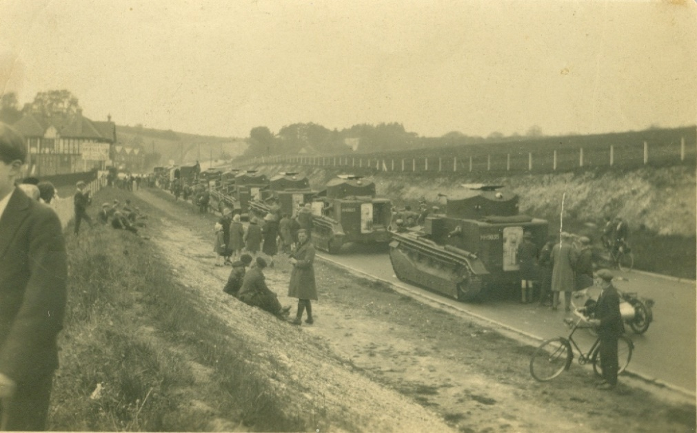

From David Hilling - Undated letter from Norman Howard (Ontario, Canada) about St Martin's bells, of which he was once a ringer; copy particulars of a 1903 peal. As a boy in 1906 he lived, as one of a family of nine, opposite the Castle Inn, and then moved to 'Pax'. (See above)
From Ian Marshall - Photo of the gathering of a fox hunt at Eynsford bridge, ?1930s.
From Patricia Walker - Wash & Brush Up by Eleanor Allen - a history of cleanliness and personal hygiene.
From Brian Wates - Entertainment Duty exemption certificate, March 1939, for film exhibition of League of Nations Union in Eynsford Village Hall.
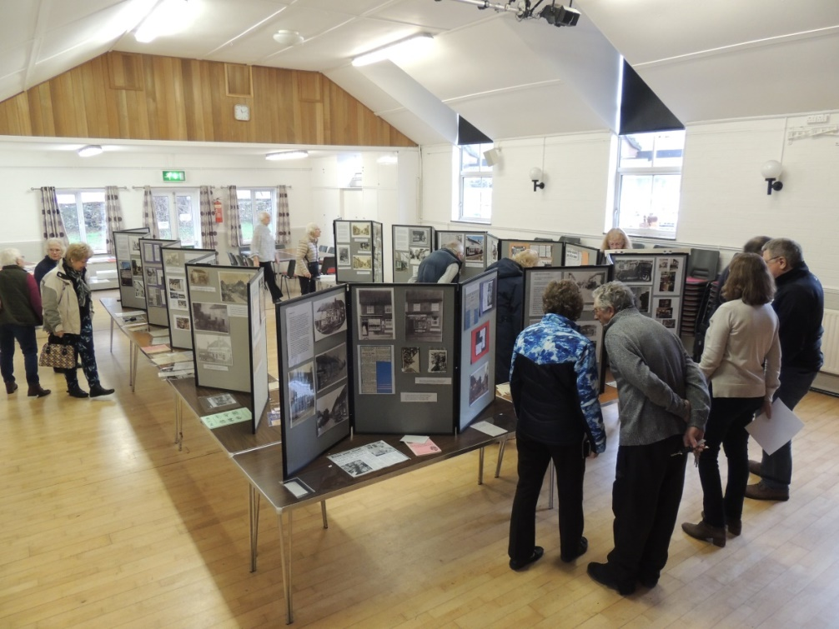

Farningham Shops Exhibition in Farningham Village Hall, 16 February 2019 - masterminded by Vikki Saunders (in grey top to right) to whom we owe thanks for the research and hard work behind this fascinating and extensive exhibition. (Photo by Trevor Allan)

WHAT’S ON ELSEWHERE IN 2019
Members of FELHS can attend free of charge if they bring proof of membership, e.g. email or other receipt of subs, or life membership card.

Horton Kirby & South Darenth Local History Society http://hksdhs.org.uk (& on Facebook)
Meetings are held on Monday at the Village Hall, South Darenth from 8 pm.
For further information, contact Barbara Cannell (01322 864253).
20 May The Kaiser’s War – Christoph Bull
8 July Lost Empires – the last days of Music Hall and Variety – Wilf Lower
9 September To be confirmed but will be a talk by a member
11 November AGM & Short Talk followed by Wine & Cheese

Shoreham & District Historical Society www.shorehamkenthistorical.org.uk
Meetings are held in the Village Hall Shoreham from 8 pm. Members who wish to attend these meetings are advised to contact the Secretary Lynda Alleeson (01959 525312) to check that no changes have been made to the programme.
19 April Knole (Vita Sackville and Harold Nicolson) - Marcia Barton
17 May The Wantsum Channell - David Carder (21 June tour of the area)
20 September The Bevan Boys - Dr Ann Kneif
18 October Unravelling the Yarn (Lullingtone silk) - Claire Weiss

Hextable Heritage Society www.hextable-heritage.co.uk (& on Facebook)
Meetings are held at the Hextable Heritage Centre, Crawfords, Dawson Drive, College Road, Hextable from 7.30 pm. For further information, please Mrs Sharon Mitchell 01322 616424.

11 April to be confirmed
9 May AGM - Hang out the Bunting - Chris Baker
13 June The Shrinking Parish of Stone - Christoph Bull
11 July Visit to be confirmed
12 September Cockney Culture - Mick Tilling
10 October Bletchley Park - Ian Thomson
14 November Victorian Leisure - Ian Bevan
5 December Christmas Social evening

