Farningham & Eynsford Local History Society
(Original Society founded 1985 Registered Charity no 1047562)
A Charitable Company Limited by Guarantee
No. 5620267 incorporated 11th November 2005 Registered Charity 1113765
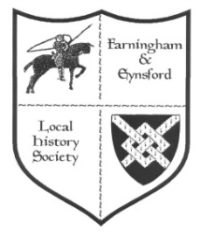

Bulletin No. 122
Autumn 2019
MEMBERSHIP SECRETARY (Alison Marshall 01322 862298)
- With this issue of the Bulletin comes the reminder to annual members to renew subscriptions. You will find a renewal form attached or enclosed, depending on your preference.
- When you complete the form please do sign the Gift Aid section if you are a tax payer because it helps the Society by making your subscription more valuable.
- Please return all completed forms to me either by post or by putting them through the door at 11a Riverside, Eynsford, Kent DA4 0AE - it is on the track to the Cricket Meadow.
- You can now find bank account details on the form if you prefer to pay by bank transfer. Otherwise please include your cheque or cash in the envelope with your form.

STILL TO COME THIS YEAR: Doors open at 7.30 pm for 8.00 pm. Display of items from the FELHS collection and light refreshments. Members free, visitors £2 (Helen Smith 01322 864234)
- Friday 8 november: eynsford Village Hall
'CREEP, PULL, PUSH - WORKERS ON THE MOVE' - Dr Jean Stirk
Motives behind the moves and how to trace moving families
- Friday 6 December: Farningham Village Hall
Films (1950s-1970s)from FELHS collection -
- Life in Farningham in the late 1950s-1960s (Sinclair film)
- 1968 Floods at Shoreham, Eynsford and Farningham
- A Vale in Kent - mostly footage of Eynsford in the 1960s
- Farningham group 'The Jaguars': Donkey Derby
2020 - FORTHCOMING TALKS AND EVENTS
Doors open at 7.30 pm for talks at 8.00 pm on Fridays. There are displays of items from the FELHS collection and light refreshments. (Helen Smith 01322 864234)
28 February Farningham VH
Villages of the Upper Darent - Ed Thompson takes us on a journey from Westerham to Lullingstone using his collection of old photographs.

27 March Eynsford VH
Mystery Artefact quiz - Martin Crowther of Canterbury Christ Church University gives us a quiz night with a difference! He challenges us with multisensory questions - historic recipes to taste, sounds, artefacts to touch and even smell. Come with a team or join others when you come.

24 April Farningham VH
Rural Rides in the Delightful Darent Valley - Christoph Bull introduces us to some of the beautiful places and astonishing people who have lived and worked in the lower Darent valley.

22 May Farningham VH
FELHS AGM - display details to be announced

Weekend 20/21 June St. Martin's Church
Exhibition on local Churches - This exhibition covering the three churches of St. Martin's, Eynsford, St. Peter & St. Paul's, Farningham, and St. Botolph's, Lullingstone, will be held in St Martin's Church - provisional times 11 am to 4 pm, and on Sunday before and after the morning service; at later dates to be announced at Farningham Church & at Lullingstone Church.

25 September Eynsford VH
Kent History from the Air - Rod LeGear, a Kent historian, who has been flying out of Biggin Hill for 25 years, will show the archaeology and historical sites in the landscape from the air.

23 October Farningham VH
Lullingstone down the Ages - Susan Pittman will highlight the depth of history over a thousand years or more of this fascinating area.

27 November Eynsford VH
A Mummers' Christmas - The Tonbridge Mummers and Hoodeners will entertain us in this Christmas special event. Singers and musicians perform traditional plays and carols. There will be an entry fee of £6 for this event, which will include Christmas fayre.

HP Laser Jet M2727 printer/ scanner/ copier
This belongs to the Society and is in working order, but has not been used because the inks get damp over winter in the Centre. It is available to anyone who can collect it and give a donation. Contact Susan Pittman

FARNINGHAM & EYNSFORD LOCAL HISTORY CENTRE
Between Riverside Social Club & Eynsford Cricket Meadow, Riverside DA4 0AE
Open: Monday 9.30 am - noon (from March-November) - and by appointment through the year.
Enquiries via archives@felhs.org.uk website: www.felhs.org.uk
Come along to visit or to help, or contact us if you have a query. Items (photos, documents, objects, memories, information) can be shared with us. We are adding to the collection all the time, and can copy precious items if you prefer to hold on to the originals. If you hear of anyone looking to dispose of any items of local interest our Centre
would ensure their future, and be of ongoing benefit to the community.

CHAIRMAN'S REPORT (Veronica Sheppard)
We are well into Autumn with no more mishaps at the Centre, and plenty of work going on there every Monday morning. In checking the videos one was wrongly labelled 'Eynsford and Farningham Cricket'. This turned out to have footage of Eynsford Cricket, and a separate film showing Farningham through the late 1960s. It turns out to be the film compiled by the Sinclair family, about which we have had several queries. We will be showing this film at the December meeting.
The Talk on 'Dirty Dartford' by Christoph Bull was very informative. Among the 'firsts' in Dartford were medicinal pills, refrigeration on ships, the tin can, and the Dandy roll for producing watermarks in paper.
We were delighted to be invited to help celebrate 70 years since excavations began at Lullingstone Roman Villa. Seven of the original diggers came and the 1950 after Dinner Speech was repeated. You can join a dig next year - look out for the Festival of British Archaeology in July 2020 - a site in the field alongside the villa car park has been chosen.
I came across this poem when flipping through Local Government, Law and Order in a Pre-Reform English Parish, 1790-1834 by Shirley Burgoyne Black. Called 'The Beauties of Farningham' by Rebecca Rogers (1775-1848), the wife of John Rogers, the Baptist Minister, the lines serve to underline the fact that much of Farningham today, for those who know it, is still very much as its inhabitants of 1790-1834 saw it. These are just the first four of fifteen verses:-
(1) My native Vale has charms for me, (2) It boasts no grand, no noble seat,
Tho' some no beauty in it see, Nor either this, or that named street
To me it is most dear; Nor number at the door;
The village with the walks around, I think I all the village know
So picturesque, the likes not found; And all the village know me, too -
I sit on this grassy mound I care not that it should be so,
And view its beauty here. For I love rich and poor.

(3) This eminence called 'Hanging Hill' - (4) The pretty church I here behold,
The walk up here delights me still, Its neighboring elms all tinged with gold,
Where our forefathers sat, The hollow ancient yew,
In harbor then both neat and gay, Whose time-carved trunk does me delight,
As I have heard my Mother say, Seems nature's frolic to the sight,
They used to pass some hours away And forms fantastic brings to light,
O'er sillabub to chat. Which fancy does construe.
RESEARCH REPORT
Susan Pittman, 01322 669923, archives@felhs.org.uk

New - Kent Archives Guide - How to Research the History of your House
We often receive enquiries about this topic, and can help out by searching our catalogue for references, photos, maps etc. This new Guide shows you how to set about the research systematically, gives ideas of what records to look at, useful websites and publications, and an abundance of useful tips. Available at £8.95 + £2 postage from Kent History and Library Centre, James Whatman Way, Maidstone ME14 1LQ: www.kentarchives.org.uk.
Roman Christianity in the Darent Valley
The claims that the Christian chapel found in Lullingstone Roman villa was the oldest in the area might have to be revised. Excavations at Church Field, Otford, of a villa, the second largest (after South Darenth) in the Darent valley, revealed the remains of a Chi-Rho symbol in part of the building demolished in the late fourth century, before or at the same time as the Lullingstone house chapel was being built.
X (chi) & P(rho) =- Greek for the first letters in capitals of Christ
(Archaeologia Cantiana 2019, pp.311-314.)

Exciting discovery of medieval graffiti in Eynsford and Farningham Churches
Wayne is an experienced archaeologist, who has worked professionally both in France and in the UK. He sent photos of graffiti he had found in St Martin's and St Peter's and St Paul's churches, and offered to give a talk on them. We already had 2020 planned, but hope he will be able to show us his findings in 2021.

Accommodation in Farningham in 1686
I do not know what generated this document (Public Record Office WO 30/48) but it lists guest beds and stabling for horses at various settlements in Kent. Farningham had 27 guest beds and stabling for 28 horses. Gravesend topped the list with 318 guest beds and stabling for 436 horses, followed by Rochester, Canterbury and Maidstone. The last in scale was Riverhill with one guest bed and no stabling for horses. In the late C17th the three routes from London to the coast were Watling Street via Dartford and Rochester to Dover; London through Farningham, Maidstone and Ashford to Hythe; London through Bromley, Sevenoaks, Tonbridge to Rye.
(The Economy of Kent 1640-1914 edited by A. Armstrong p.128/286)

Eynsford Baptist Chapel, new in 1806
In the last Bulletin I mentioned the donation of research and photos related to the Bowers family. I promised to write more about the connection of George Bowers (1770-1859) with the building of the first dedicated Baptist Chapel in Eynsford in 1806. Before that Baptists had met as house groups, until a stable had been fitted up as a make-shift Chapel in 1799.
George and Mary Bowers arrived in the area in 1805 from Penn, Buckinghamshire, where they had worshipped as Particular Baptists (a rigid form of belief). George was a
papermaker by profession and went to work in Eynsford Paper Mill. His arrival coincided
with the need of the Eynsford Baptists to build their own Chapel, because their numbers had
increased so much, and he was almost immediately chosen to be on the Building Committee.

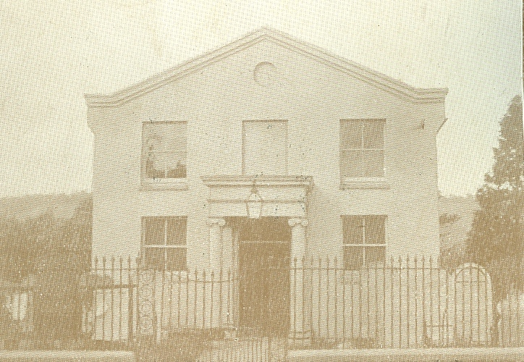
The Baptist congregation soon leant heavily on his considerable abilities, and after the new Chapel was opened on 2 July 1806 he was appointed with two others to look after it. He was also asked to audit the deacons, and was elected unanimously to become a deacon himself. Marianne Farningham, one of his grand-daughters, recalled him as a 'very fine man', in her family's kitchen smoking a long clay pipe, with a glass of home-brewed beer on the table. His conversation mainly focused on religious debate, and he would often preach not only in Eynsford, but walked many miles to surrounding villages. The Chapel of 1806 lasted a century until replaced by the present building in 1906.
(Pamphlet The Eynsford Baptist Chapel 1806-1906; A Farningham Childhood: Chapters from the Life of Marianne Farningham edited by Shirley Burgoyne Black)

Even more about Rose Marchant (1870-1939)
I could almost serialise this entry, because it is the third Bulletin to mention her! The reason is that a great x2 grandson of Rose's father, Henry Marchant, has made contact, having read the previous Bulletins. Henry Marchant was in business with Thomas Everest as wheelwrights, and later as builders and contractors. Both were married into the Everest family - as was Sydney Lee, and David remembers a letter from Sydney Lee to Rose Marchant, starting 'Dear Cousin'. I put David in touch with Sue, an Everest who has researched the family in detail, and they found they too were distantly related. Between David and Sue several family photos have been added to the collection at the Centre, including one of Rose Marchant. There is also a copy of her will, in which she left £38,752. Her freehold house and £3,000 went to Sydney Lee, her executor; £10,000, her residence (Hillfield) and other real estate to her niece, Edna Grace Crowhurst; £1000 to Harold Lee, brother to Sydney; £5000 in trust to her great-niece, Sylvia Rose Mary Crowhurst, five other personal bequests, and others to various charities. Even after all that marvellous information the original mystery of why Rose Marchant was the chief beneficiary in Loftus Edgar Lambourn's will remains. It has been confirmed, however, that Lambourn Brothers (Loftus and Charles) had a pianoforte and music store in Orwell Road, Felixstowe, in 1912.
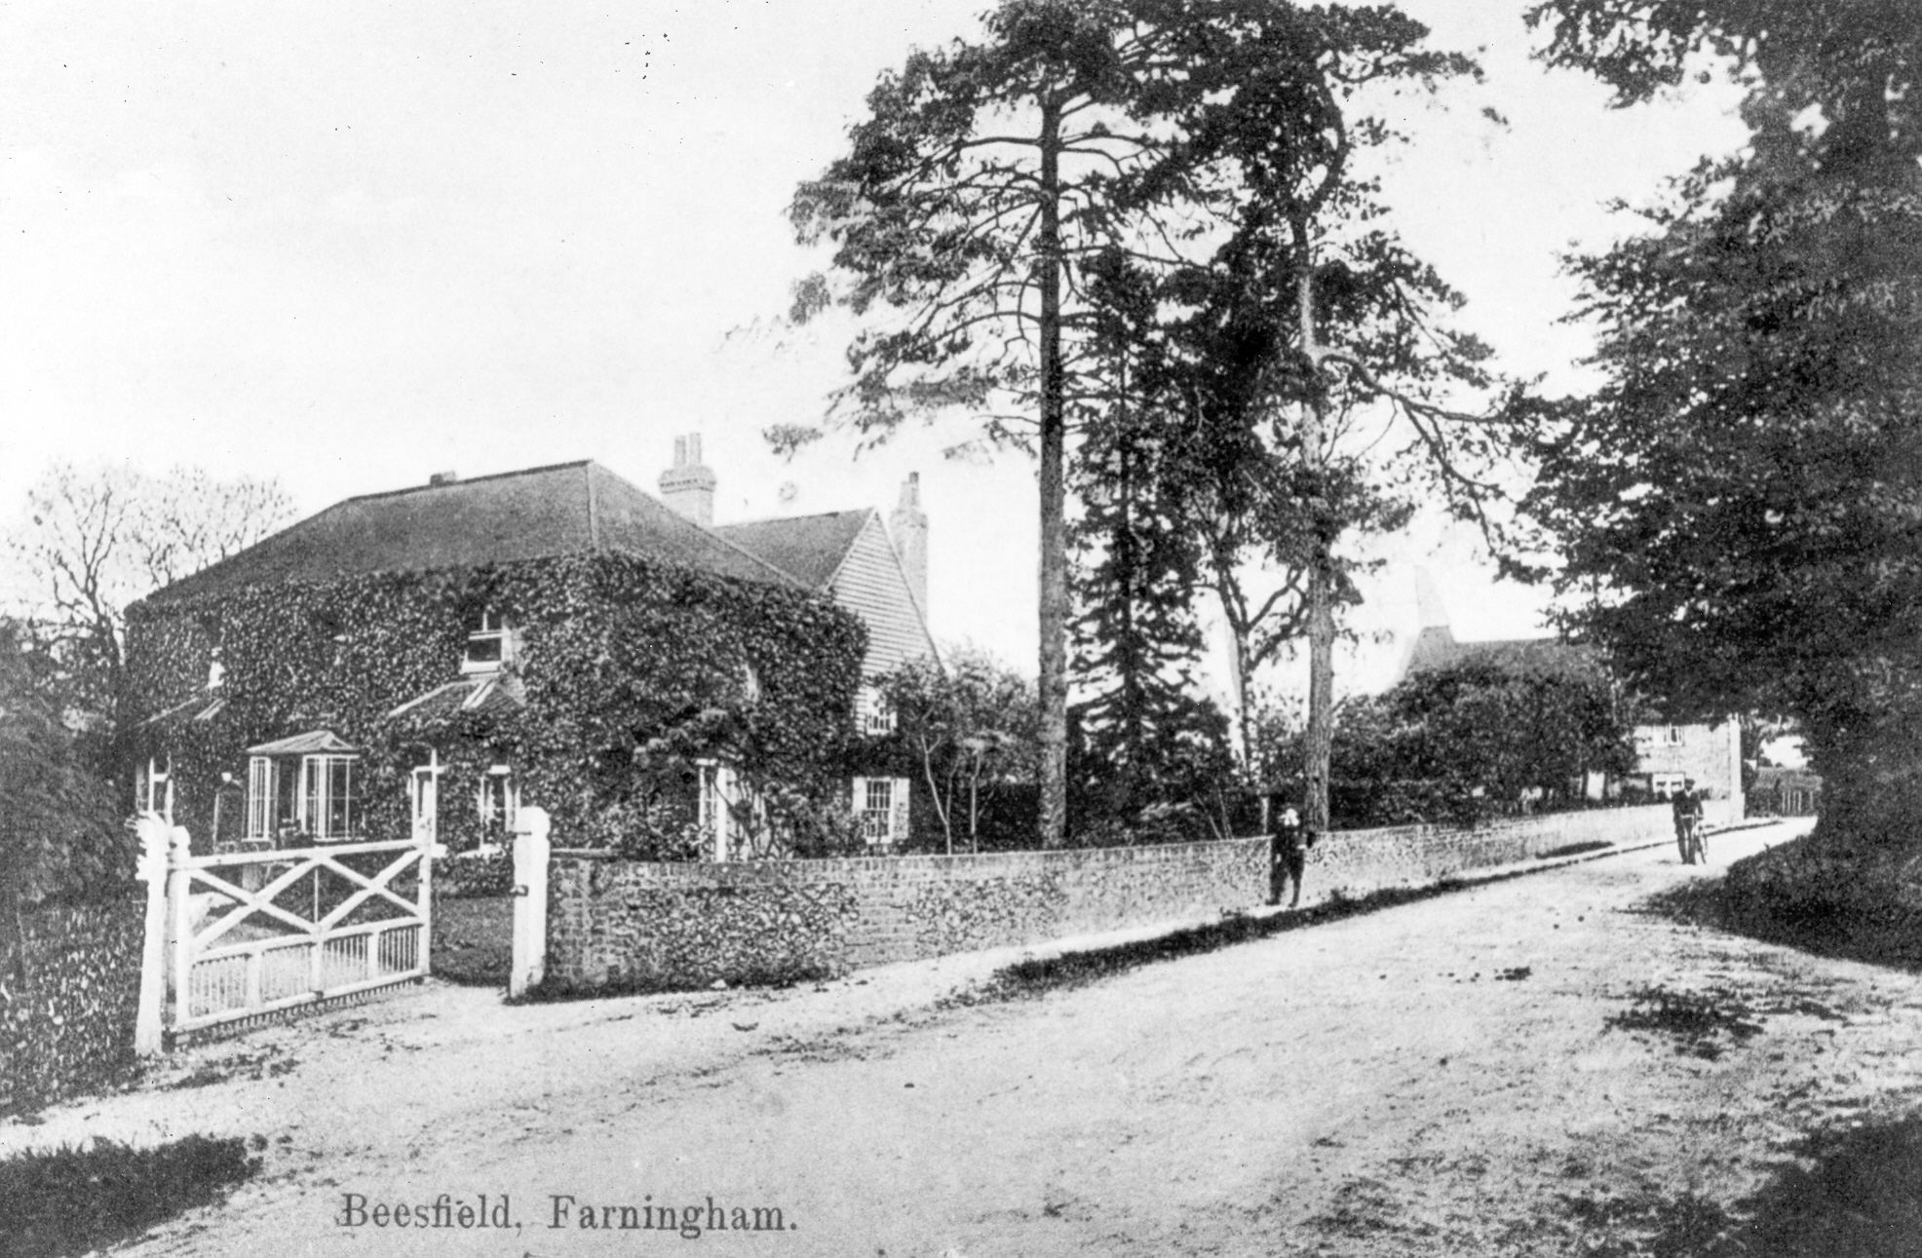

Beesfield Farm, Farningham. In the 1890s Henry Marchant owned Beesfield Farm, which he let to John Crowhurst, who subsequently took over the tenancy of Charton Farm.

Built by Henry Marchant:
Lychgate at Farningham Church
Stocks in Eynsford
Repairs to Eynsford Church tower
Braeside, Farningham, now demolished
Extension to the Old Parsonage, Farningham
Hillfield, Gorse Hill, Farningham
Catherine and Mary Villas, White Post Hill

Bomb falling in Cray Road, Crockenhill, 11 March 1941 - Four Fatalities
There were four fatalities, recorded on the war memorial plaque inside All Souls Church, Crockenhill, when a house in Cray Road suffered a direct hit from a stick of bombs ejected by a German bomber returning from a raid on London. A contact of a relative of William Perfect, one of six rescuers who rushed to the scene, has provided copies of documents kept by the family after the event. The six rescuers were awarded the King's Commendation for Brave Conduct in Civil Defence, and were officially thanked by the Regional Commissioner of Civil Defence, by the Rural District Council of Dartford and their names were published in the London Gazette. A local paper included photos of the six alongside an account of the explosion and subsequent recovery of the dead and the survivors.
The Dead: John and Eden Wellard, Maud Packham, Jimmy Moffat (aged 12)
Rescuers: P.C. Jack Darkins, James Packman, John Nichols, Albert Playfoot, William Perfect, George Groombridge
(I am currently preparing for publication the history of John Wood and family of The Mount, Crockenhill. It was one of their workers' houses that was hit, so I am including a more detailed account of the air-raid in it. Please contact me if you have information about this farming family.)

General Enquiries
Walter Gordon Wilson - Fidelix from Itchen Abbas in Hampshire requested information because he lives in the village where Wilson lived in later life and died. I sent him a copy of Wilf Duncombe's FELHS publication 22, Walter Gordon Wilson; Engineer and Tank Pioneer.
Economic Motors Ltd. - Steve wanted information on the motorcycles and cyclecars produced by Primrose Works, Lullingstone. This was the factory run by Oliver Hart Dyke in the area now occupied by Lullingstone Roman Villa car park. Steve visited the Centre to see the folder on Victor/ Economic motors and examined the Victor motor cycle engine we have. He bought a copy of Wilf Duncombe's article in FELHS publication 19, Miscellany of Local History Papers no.1. He complemented the Society on its wonderful resource.
The Place Identity of Eynsford - Steven, a Subject Leader of Geography, wanted information for part of an A-level course. I offered to see him over the summer, but he made no further contact.
Woods Cottages, Crockenhill, and the Smith family - Margaret is researching her husband's Smith ancestors, one of whom, James Smith, worked as an engine driver for Thomas Wood, but by 1891 was living in Trottescliffe. I asked for more family details, but Margaret has not got back in touch.
Farningham bridge - Farningham Parish Council clerk enquired about the plaques on Farningham bridge. I suggested the purchase of Wilf Duncombe's FELHS publication 33, The Bridges of Eynsford and Farningham.
Hodsoll family - John Drew, who wrote the booklet on the Cricket Match between Shoreham and Farningham in 1940, When War Stopped Play, is researching another aspect of cricket and enquired about the location of the Hodsoll papers. He remembers going to school in Hodsoll House in Farningham High Street and seeing the wealth of family papers held by James Hodsoll, the then owner of the house. The Drew family paid him 4 guineas (£4 - 20p) rent for Vicarage Cottage. Any help with tracking down these family archives would be appreciated. I have found some documents held by Kent Archaeological Society.
Bomb in Cray Road, Crockenhill - Stuart provided copies of documents from William Perfect's family. (See above)

Family History
Joseph Holdstock - Steve and his family used to live in Farningham and then in Eynsford, until the family emigrated to Australia in 1997. His nephew lives in St Martin's Drive. Steve was enquiring about his wife's family, Holdstock. I e-mailed a family line of the Joseph Holdstock, who is listed on the Eynsford War Memorial. His name was added last because he died in 1921, after a lingering death following gassing. The family came from Benenden, and Steve found these details useful. I will add his immediate line to the records at the Centre, because two others have previously enquired about the family.
Hinsby/ Colyer - Terese is related to Maria Hinsby, who is remembered on the Colyer/ Hinsby tomb in St Peter and St Paul's churchyard. She had tried to record the inscriptions of this impressive monument, but the stone is flaking away. I have been unable to track down a recording of the inscription when it was intact, but checked her attempt, and provided details of the names from the Farningham registers.

ARCHIVE REPORT
Susan Pittman - 01322 669923, www.felhs.org.uk
We continue to find plenty of jobs to do to make the collection more accessible and meaningful. Helen and Ann have completed working through James Alexander's slides labelled 'Old Eynsford' and added the captions on the digital copies; Ann (on the occasional absence of Helen) and Vikki are trying to catch up with backlog of cuttings for the Farningham Scrapbooks; Veronica and I have been checking the library and adding the books to the main catalogue, rather than having a separate book catalogue.
One Monday we were alarmed by an explosion and the smell of burning, which came from one of the light fittings. We turned off the electricity, and were able to contact an electrician the next day - within hours he put in a new fitting - marvellous!
Just a reminder that we close the Centre on Monday mornings from November through to March, but you can always make contact if you would like to use our services.

Acquisitions
From Helen Goldsworthy - Order of Service for the Opening & Dedication of the Order of St. John's Ambulance Brigade Headquarters 21/7/1935; map of Dartford Rural District with Farningham parish highlighted - no date but judging by lack of development ?1890s.
From Jean Middleton - Mug celebrating 100th anniversary of Eynsford WI, 1919-2019.
From Rebecca Silk - Bound volumes of Eynsford Church Monthly 1889-1890, 1895-1896, 1897-1898 (these filled gaps between other volumes in the collection).

WHAT’S ON ELSEWHERE IN 2019
Members of FELHS can attend free of charge if they bring proof of membership, e.g. email or other receipt of subs, or life membership card.
Horton Kirby & South Darenth Local History Society
http://hksdhs.org.uk (& on Facebook)
Meetings are held on Monday at the Village Hall, South Darenth from 8 pm.
For further information, contact Barbara Cannell (01322 864253).
13th January Doing our bit – Steve Hookins
9th March Dartford Rural Rides – Christoph Bull
18th May Murder, Madness & Mayhem – the Belgian Royal Family Melanie Gibson-Barton
13th July Up the Junction (Old Swanley) part 2 – Keith Whitworth
14th September Leeds Castle – Ann Kneif
9th November AGM, Short Talk followed by Cheese & Wine
Shoreham & District Historical Society
www.shorehamkenthistorical.org.uk
Meetings are held in the Village Hall Shoreham from 8 pm. Members who wish to attend these meetings are advised to contact the Secretary Lynda Alleeson (01959 525312) to check that no changes have been made to the programme.
17th January Dr Lothian Lecture: The History of a Mattress - Dr Mary Bliss
21st February The Craft of the Clock Maker
20th March Water Mills of the Darent - Dr Lionel Parks
24th March Dene Holes & Sink Holes - Mike Clinch KAS
Hextable Heritage Society
www.hextable-heritage.co.uk (& on Facebook)
Meetings are held at the Hextable Heritage Centre, Crawfords, Dawson Drive, College Road, Hextable from 7.30 pm.
2020 Programme to be confirmed
For further information, please Mrs Sharon Mitchell 01322 616424.
